Daniel Pham Comp 421

260 526 252 2015/02/13

Question 1:

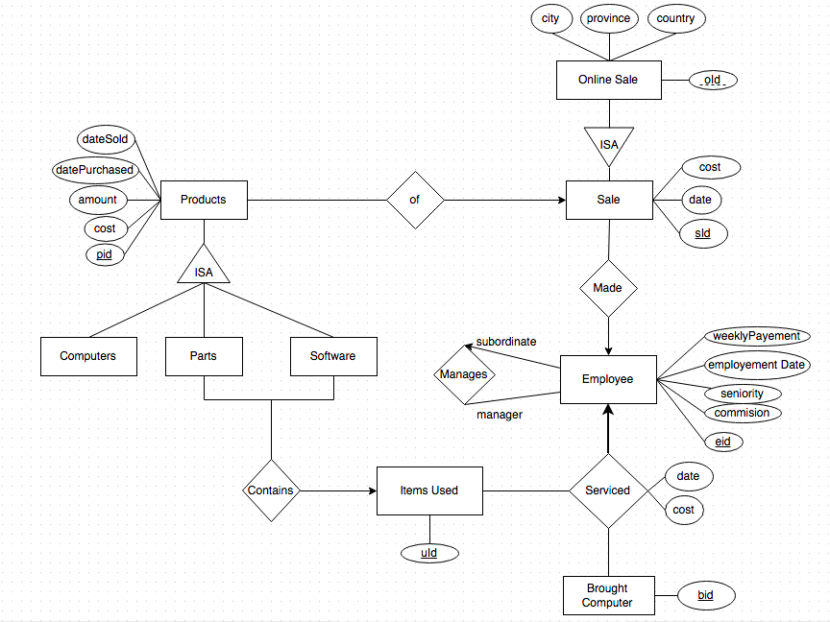

Employee(eid, weeklyPayement, employementDate, seniority, commission)

Sale(sid, date, cost)

OnlineSale(sid, oid, date, cost, city, province, country)

ItemUsed(uId)

Products(pid, amount, cost, datePurchased, dateSold)

BroughtComputer(bid)

Manages(eid, eid)

Made(eid, sid)

Serviced(eid, bid, uId, date, cost)

Contains(uId, pid)

Of(sid, pid)

Question 2:

Department (did, deptName, administrator, numberOfBeds)

Employee (MedicareNumber, did, firstName, lastName, jobTitle, startDate, lastDate, gender, dateOfBirthob, phone#, email, address)

Patient (medicareNumber, firstName, lastName, gender, dateOfBirth, phone#, address*)

Admission (date, MedicareNumber, DoctorId*,* reasonForAdmission, dateAdmitted, dateDischarged)

Visit (time, date, MedicareNumber, DoctorId*,* diagnosis, medicalReport)

Doctor (MedicareNumber, DoctorId, specialty, visitFee)

Nurse (MedicareNumber, NurseId, specialty)

1. List the information of all doctors who are specialized is heart surgery.

σSpecialty = heart surgery(Employees ⋈ Doctors)

1. List the information of all nurses who are from Laval and started since June 01, 2012.

σAddress = Laval ∧ startDate > June 01 2012 (Employees ⋈ Nurses)

1. Given a patient’s Medicare number, list the Medical Report of that patient.

**ΠmedicalReports(**σmedicareNumber = query(Visit))

1. Given a patient’s Medicare number, find out how much s/he has paid for each visit since June 2014.

**ΠvisitFee(**σmedicareNumber = query ∧ date > June 2014(Visit ⋈ Doctor))

1. List heart patients who were admitted/visited at least twice.

ρ(VisitPair, Visit)

ρ(VisitedTwice, σVisitPair.MedicareNumer = Visit.MedicareNumer ∧

Visit.diagnosis = ‘Heart’ ∧

VisitPair.time ≠ Visit.time(Visit x VisitPair))

ρ(AdmissionPair, Admission)

ρ(AdmittedTwice, σAdmissionPair.MedicareNumer = Admission.MedicareNumer ∧

Admission.reasonForAdmission = ‘Heart’ ∧

AdmissionPair.dateAdmitted ≠ Admission.dateAdmitted (Admission x AdmissioPair))

ΠMedicareNumber(VisitedTwice) ∩ ΠMedicareNumber (AdmittedTwice)

1. List patient’s first name, last name, phone, date admitted, date discharged for all admitted patients with Cancer or HIV.

**Πc(**σreasonForAdmission = ‘Cancer’ ∨ reasonForAdmission = “HIV’(Admission ⋈ Patients))

C: firstName, lastName, phone, dateAdmitted, dateDischarched

1. List patient’s first name, last name, phone, date admitted, date discharged for all admitted patients with Cancer and HIV.

**Πc(**σ(reasonForAdmission = ‘Cancer’(Admission ⋈ Patients) ∩

σ(reasonForAdmission = ‘HIV’(Admission ⋈ Patients))

C: firstName, lastName, phone, dateAdmitted, dateDischarched

1. List patient’s first name, last name, phone, date admitted, date discharged for all admitted patients with Cancer but do not have HIV.

**Πc(**σ(reasonForAdmission = ‘Cancer’(Admission ⋈ Patients) -

σ(reasonForAdmission = ‘HIV’(Admission ⋈ Patients))

C: firstName, lastName, phone, dateAdmitted, dateDischarched

1. List patient’s first name, last name, phone, date admitted, date discharged for all admitted patients who are doctors.

**Πc**(Admission ⋈ Patients ⋈ Doctors)

C: firstName, lastName, phone, dateAdmitted, dateDischarged

1. List employee's first name, last name, jobTitle, phone# of employees who are patients and diagnosed with HIV.

**Πc(**σdiagnosis = “HIV’(Patients ⋈ Employee ⋈ Doctors)

C: firstName, lastName, jobTitle, phone